Basic Logging & Monitoring in MinIO

1. Introduction

Logging and monitoring are foundational operational practices for maintaining the availability, performance, and reliability of a MinIO object storage deployment. MinIO provides several native mechanisms—such as the MinIO Console, mc admin commands, system service logs, and audit logs—that allow administrators to observe system health and diagnose issues without relying on external monitoring stacks.

2. MinIO Console Overview (If Enabled)

Description

The MinIO Console is a web-based administrative UI (usually exposed on port 9001) that provides a high-level view of the MinIO server or cluster.

What the Console Shows
- Server and node status
- Storage usage
- Bucket and object activity
- Basic health indicators

Example

When MinIO is started with:

minio server /mnt/data --console-address ":9001"

The console becomes available at:

http://<server-ip>:9001

Use Case
- Quick visual verification that MinIO is running
- Demonstrations and basic administrative checks in labs

3. Node Status

Description

Node status indicates whether MinIO nodes are online, reachable, and operational.

Using mc to Check Node Status

mc admin info myminio

Key Indicators
- Node address and name
- Uptime
- MinIO version

Use Case
- Detecting node outages in single-node or distributed setups
- Confirming successful restarts or upgrades

4. Drive Health

Description

Drive health reflects whether storage disks used by MinIO are online and writable.

Command Example

mc admin info myminio

What to Observe
- Total drives
- Online drives
- Offline or missing drives

Use Case
- Identifying disk failures
- Diagnosing read-only filesystem or permission issues

5. Cluster Readiness Indicators

Description

Cluster readiness indicates whether MinIO is ready to accept client requests.

Health Check Command

Curl -I http://127.0.0.1:9000/minio/health/live

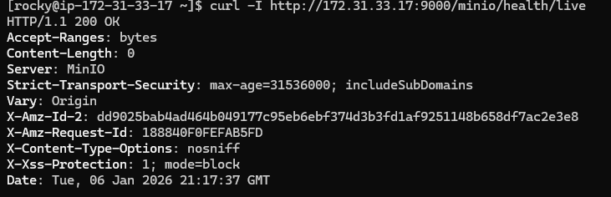

Curl -I http://127.0.0.1:9000/minio/health/ready
Expected:

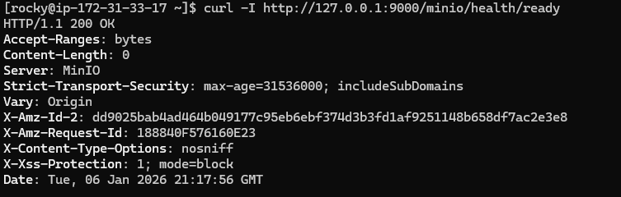Use Case
- Load balancer readiness probes
- Startup validation during automation

6. Server Logging

Description

MinIO writes operational logs (startup, warnings, errors) to standard output. When MinIO runs as a systemd service, these logs are captured by journald.

7. journalctl / Service Logs

Viewing MinIO Logs

sudo journalctl -u minio

Time-Based Filtering

sudo journalctl -u minio --since "1 hour ago"

Use Case
- Troubleshooting startup failures
- Diagnosing runtime errors
- Root cause analysis after incidents

8. Typical Warning / Error Patterns

Common Log Messages
- Disk errors: permission denied, drive not found
- Network errors: unable to bind port, connection refused
- Authentication errors: invalid access key, signature mismatch

Use Case
- Quickly mapping log messages to operational problems
- Training administrators to recognize failure symptoms

9. Audit Logging

Description

Audit logging records who did what and when in MinIO. It is critical for compliance and security monitoring.

10. Enabling Audit Logs

Audit logs are enabled by configuring MinIO to send audit events to a target (file, webhook, or logging system).

Use Case
- Compliance (finance, healthcare, government)
- Security investigations

11. What Actions Get Logged

Audit logs capture:
- Object uploads and downloads
- Object deletions
- Bucket creation and removal
- Authentication attempts
- Policy and IAM changes

12. Reading Simple Audit Entries

Typical Audit Fields
- Action performed
- Timestamp
- Result (success or failure)

Use Case
- Tracking unauthorized access attempts
- Forensic analysis after incidents

13. Using mc admin for Health Checks

mc admin info – Cluster Summary

mc admin info myminio

Provides:
- Node summary
- Storage usage
- Version and uptime

mc admin heal – Heal Status

mc admin heal myminio

Shows:
- Ongoing heal operations
- Failed or pending disk repairs

Use Case
- Monitoring self-healing behavior
- Validating recovery after disk failures

14. Simple Alerting Patterns

Health Check Scripts

Administrators often wrap MinIO health checks in scripts:

mc admin health myminio || exit 1

Exit Code Checks
- Exit code 0 → healthy
- Non-zero → unhealthy

Use Case
- Cron-based monitoring
- Integration with basic alerting systems

15. Basic Ping-Based Service Validation

Description

Ping-based checks validate network reachability, not application health.

Example

ping <minio-server-ip>

Limitation
- Ping success does not guarantee MinIO service health

Use Case
- Network troubleshooting
- Initial connectivity checks

